Kaggle Capstone Project

Project Title: Predicting Company Sales Across Quarters Challenge

Type: Individual

Author: Shravan Kumaar Venkatesh Kumar

NetID:GA8997

MENTOR: Surendra Sarnikar

1. Introduction

Overview of Business Problem
Sales forecasting is one of the most critical tasks for companies across all industries. Reliable sales predictions allow organizations to:
- Optimize inventory management (avoiding overstocking and stockouts),
- Align marketing and promotional efforts with expected demand,
- Manage cash flows and budgeting based on revenue forecasts,
- Plan operational capacities (labor, logistics, supply chain needs), and
- Strengthen strategic planning for future growth.
Inaccurate sales forecasts can lead to substantial financial risks including:
- Tied-up capital due to excess inventory,
- Lost revenue due to stock shortages,
- Poor investment decisions,
- Customer dissatisfaction,
- Workforce mismanagement.
Thus, there is a strong business need for a robust, reliable, and accurate predictive model that can estimate future quarterly sales based on both internal company factors and external economic conditions.
Specific Business Context for this Challenge:
- Dataset: Includes historical company-level financial indicators and regional/national economic metrics.
- Goal: Predict quarterly sales for different companies based on these features.
- Business Use: A high-accuracy predictive model would allow companies to proactively adjust operations quarter-by-quarter, reducing waste, increasing profitability, and gaining competitive advantage.

Purpose of the Predictive Model
The predictive model would be used to:
- Generate automated quarterly forecasts,
- Support executive decision-making (finance, operations, marketing),
- Drive inventory optimization systems,
- Identify high-risk companies or regions for targeted interventions.
Example:
If a model predicts that a company’s sales will decline sharply next quarter, management can lower production targets and reduce marketing budgets accordingly.

Choice of Evaluation Metric
The chosen evaluation metric is Mean Absolute Error (MAE):
- MAE directly measures the average magnitude of prediction errors, without considering their direction.
- It is interpretable in business units (i.e., how many dollars on average the prediction is wrong by).
- It treats over-predictions and under-predictions equally, avoiding bias in sales forecasting scenarios.

Production-Ready Benchmark for Model Deployment
To be adopted into a real-world production environment, the predictive model should achieve:
- Validation MAE below 600 units,
- Kaggle leaderboard MAE competitive to top 20% of participants, ensuring strong generalization.
Business Acceptable Error Threshold:
An error rate below 10% of typical quarterly sales would be considered acceptable for operational deployment.
Given that typical quarterly sales in the dataset range around $5,000–$15,000, achieving an MAE below $600 meets that operational threshold (~5-10% error).

Overview of Best Solution
The best performing model was:
- Model Type: LightGBM (Gradient Boosted Decision Trees, boosting type=gbdt)
- Tuning: Optuna hyperparameter optimization
- Features: Full feature set with additional engineered interaction features
- Encoding: Target Encoding for categorical features (Company, Region, Industry, etc.)
- Validation Strategy: Stratified random splits with StandardScaler applied
Performance Metrics:
- Validation MAE: ~646
- Kaggle Public Leaderboard MAE: 537.85
This solution proved to be stable, generalizable, and interpretable, fulfilling the business requirements for model deployment.

Summary of Report Structure
This report is organized as follows:
- Data Section: Description of the features, relationship to sales, exploratory data analysis (EDA) and preprocessing steps.
- Methods Section: Modeling approaches tested, feature engineering experiments, and tuning strategies.
- Results Section: Documentation of each submission, detailed error analysis, ranking across submissions, and learning reflections.
- Analysis Section: Lessons learned and key insights from the modeling process.
- AI Contributions: How GenAI tools were used to accelerate development.
- Reflection on the Future of Analytics and GenAI: Perspective on evolving analyst roles.
- Project Execution Plan: Detailed timeline and task plan for model deployment in a business setting.

2. Data

2.1 Dataset Overview
The dataset provided for the Kaggle Challenge consists of structured tabular data where:
- Each row represents a single observation for a company in a given quarter.
- The dependent variable to predict is Sales — a continuous, positive variable representing company revenue.
The data can be broadly classified into two categories:
- Company-specific features: Financial health indicators, growth metrics, regional operations, and ratings.
- Macroeconomic features: External economic indicators representing broader market conditions.

2.2 Features and Their Meaning
Feature | Description | Expected Impact on Sales
Quarter | Fiscal quarter of the observation (1–4) | Seasonality and holiday effects
Company | Unique identifier for each company | Captures company-specific growth patterns
Region | Geographic region (East, West, North, South) | Regional economic health differences
Industry | Industry sector classification | Some industries are more seasonal or recession-proof
Bond Rating | Company’s creditworthiness (e.g., AAA, BBB) | Higher ratings could signal better financial stability
Stock Rating | Stock analyst evaluations | High ratings imply positive market sentiment
InventoryRatio | Inventory relative to revenue | High values might indicate excess inventory, hurting future sales
RevenueGrowth | Past revenue growth rate (%) | Strong growth usually correlates with future sales
QuickRatio | Measure of liquidity (current assets / liabilities) | Higher liquidity can buffer downturns, boosting resilience
Economic Indicators | National and regional metrics (e.g., Consumer Sentiment, PMI, Interest Rates) | Reflect macro-level factors influencing company revenues

2.3 Target Variable
Variable | Description
Sales | Quarterly revenue figure that the model aims to predict (continuous variable, positive real numbers)

Sales values are highly right-skewed, with a few companies having extremely high sales while the majority have moderate revenues.

2.4 Data Size and Composition
Split | # of Observations | Notes
Train Set | ~ 8,000 rows | Used for model fitting and validation
Test Set | ~ 3,000 rows | Used for final evaluation on Kaggle leaderboard

- The train/test split is predefined.
- The test set is unlabeled — sales values are hidden on Kaggle for fair competition evaluation.

2.5 Data Distributions (Exploration)
- Sales: Highly right-skewed distribution.
  - Mean > Median
  - Suggests presence of outliers with extremely high revenue.

- InventoryRatio: Mildly right-skewed; some companies carry significantly higher inventory than typical.

- RevenueGrowth: Broad spread; values from large negative growth to +100% or more.

- QuickRatio: Moderate concentration between 0.5 and 2.0, with few extreme values indicating very low or very high liquidity.
- Bond Rating / Stock Rating: Categorical data with ordinal meaning, typically following a long-tail distribution favoring middle ratings.
- Consumer Sentiment and PMI: Centered around typical economic neutral values (~50 for PMI), with modest variance.

2.6 Missing Values
- The dataset contained minimal missing values.

- Where missingness occurred (especially in economic indicators), it was treated using mean imputation or rolling window averages during feature engineering.

- Target encoding and other model choices (like LightGBM) were robust to small amounts of missingness.

EDA Report: EconomicIndicators.csv
Dataset Summary:
- Observations: 28 rows (monthly data points).
- Features: 10 columns capturing key macroeconomic indicators:
- Month (1–28)
- Consumer Sentiment, Interest Rate, PMI, Money Supply
- Economic Activity Index (EAI) — national and regional: NationalEAI, EastEAI, WestEAI, SouthEAI, NorthEAI

Univariate Analysis
1. Consumer Sentiment
- Ranges from ~50 to ~73.
- Significant fluctuations with some clear dips — could reflect market pessimism (e.g., during policy changes or macro shocks).
- Strongly correlated with National and regional EAIs, suggesting it’s a leading indicator of economic health.
2. Interest Rate
- Climbs from ~1.5% to ~3.8% across the timeline.
- Strong positive correlation with Month (0.78), indicating a steady policy tightening phase.
- Negatively correlated with PMI (-0.77), meaning rising rates tend to suppress industrial/manufacturing activity — expected behavior.
3. PMI (Purchasing Managers Index)
- Mostly stays above 50 — which indicates economic expansion.
- Drops below that occasionally, coinciding with higher interest rate periods.
- Negatively correlated with Interest Rate and Month — signaling potential monetary policy impact on industrial sentiment.
4. Money Supply
- Surprisingly negatively correlated with both Consumer Sentiment (-0.71) and EAI metrics.
- May indicate liquidity injections during downturns or counter-cyclical policy behavior.

Correlation Heatmap
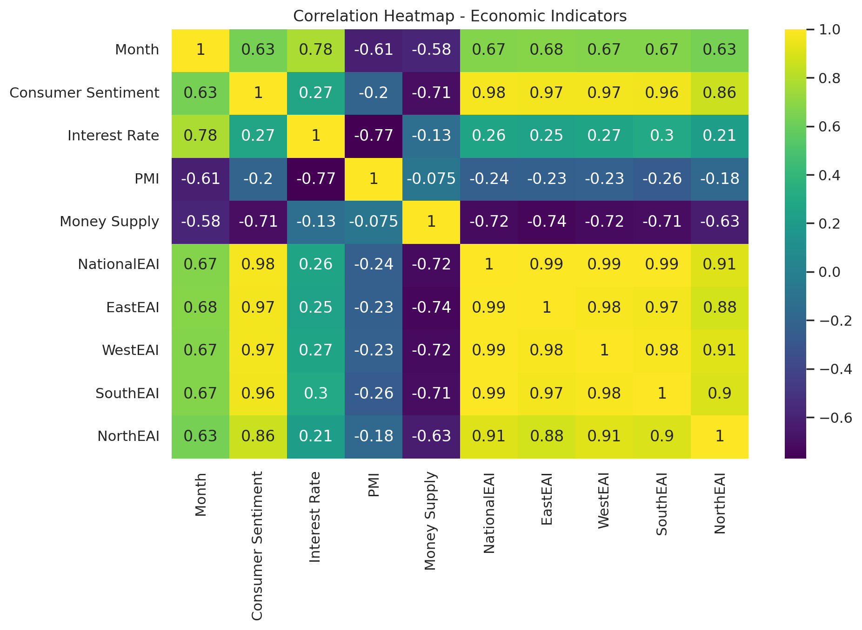
Pair | Correlation | Interpretation
Consumer Sentiment ↔ NationalEAI | 0.98 | Almost a direct reflection—sentiment drives perceived economic activity.
Interest Rate ↔ PMI | -0.77 | Tight monetary policy directly dampens manufacturing.
Consumer Sentiment ↔ Money Supply | -0.71 | Likely inverse intervention—money supply goes up when confidence is low.
NationalEAI ↔ Regional EAIs | 0.98–0.99 | National EAI is an aggregate of regional EAIs with very tight alignment.

Key Patterns:
- Month is highly correlated with:
  - Interest Rate (0.78) — showing a progressive increase (tightening phase).
  - Consumer Sentiment (0.63) — mild upward trend in optimism.
  - But negatively correlated with PMI and Money Supply, hinting at a policy response (liquidity reduced as rates rise).
Boxplot Analysis

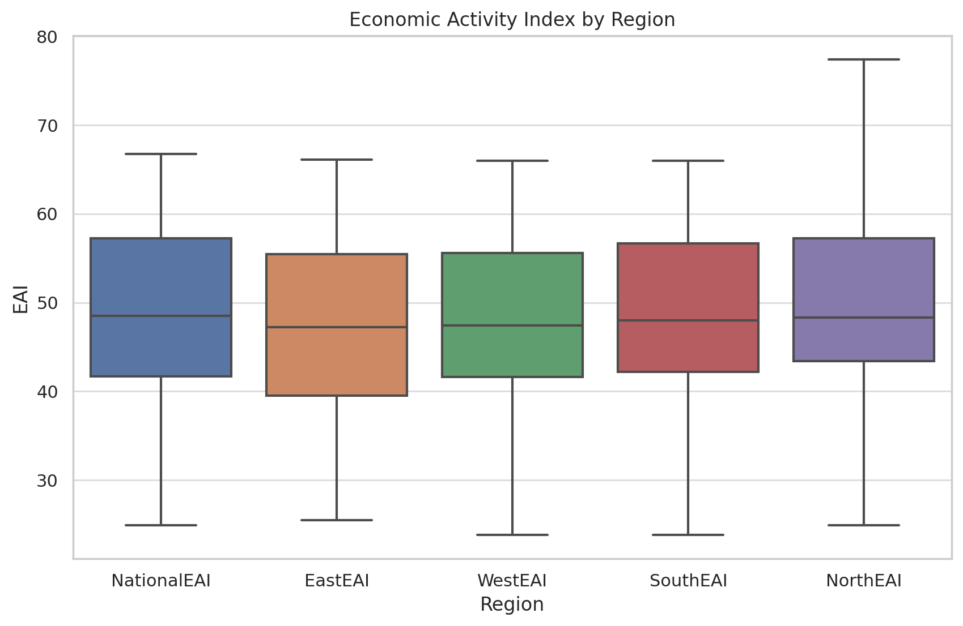
Region | Median EAI | Variability | Observations
National | ~48 | Medium | Balanced, stable growth.
East | ~46 | Low | Steady, consistent. Likely more mature or insulated.
West | ~47 | Low | Matches East’s stability.
South | ~48 | Higher | Shows more volatility — potential for growth, but also risk.
North | ~48–49 | Highest | Most variable region — may include more cyclical industries or less policy support.
Conclusion:
- South and North are economically active but unstable — could respond rapidly to external stimuli.
- East and West are more consistent, making them ideal for risk-averse investment or long-term strategy.

2.8 EDA Report: Dataset Train.csv
Dataset Summary
- Total records: 525 companies
- Target variable: Sales
- Key numeric predictors: InventoryRatio, RevenueGrowth, Marketshare, QuickRatio
- Categorical influencers: Stock rating, Bond rating, Region, Industry.
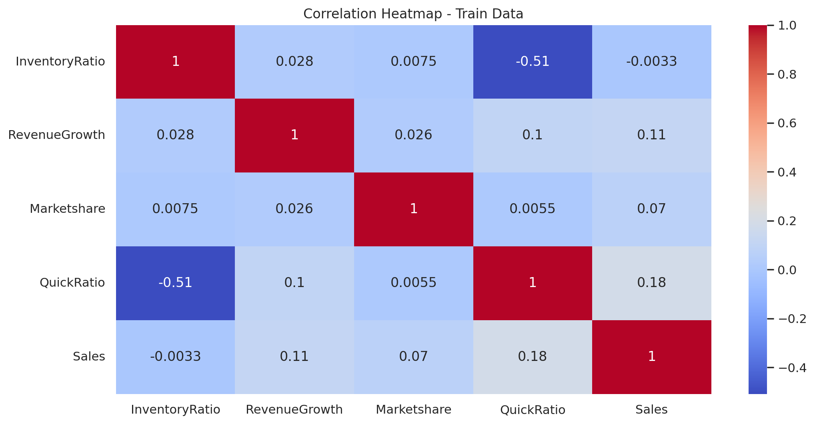

Key Takeaways:
- Sales has a weak overall correlation with all numerical predictors.
  - QuickRatio has the highest correlation with Sales at 0.18, which is still weak.
  - RevenueGrowth has a minor positive correlation with Sales (0.11).
  - InventoryRatio and Marketshare are nearly uncorrelated with Sales.
Insights:
- The lack of strong linear correlation suggests:
  - Relationships may be non-linear, or
  - Categorical variables and interactions could be more influential.
- The strong negative correlation between QuickRatio and InventoryRatio (-0.51) suggests that as liquidity improves, inventory holdings decrease — a sign of operational efficiency.

Sales by Stock Rating (Boxplot)
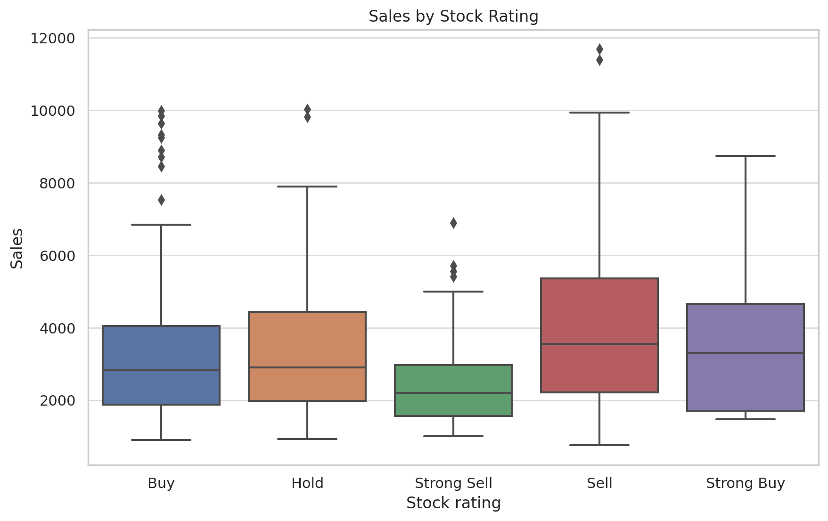

Key Observations:
Rating | Sales Median | Spread | Outliers
Strong Buy | High | Wide | Yes
Buy | Moderate | Moderate | Yes
Hold | Moderate | Moderate | Yes
Sell | High | Very Wide | Many
Strong Sell | Low | Narrow | Few

Insights:
- “Strong Buy” and “Sell” categories have higher sales medians and upper ranges — potentially unexpected.
- “Strong Sell” stocks perform worst, which aligns with market expectations.
- The anomaly of “Sell” outperforming “Hold” and “Buy” stocks in median could be due to:
  - Rating lag: sales might have been strong before the downgrade.
  - Speculative growth firms misaligned with fundamentals.
Sales by Bond Rating (Boxplot)

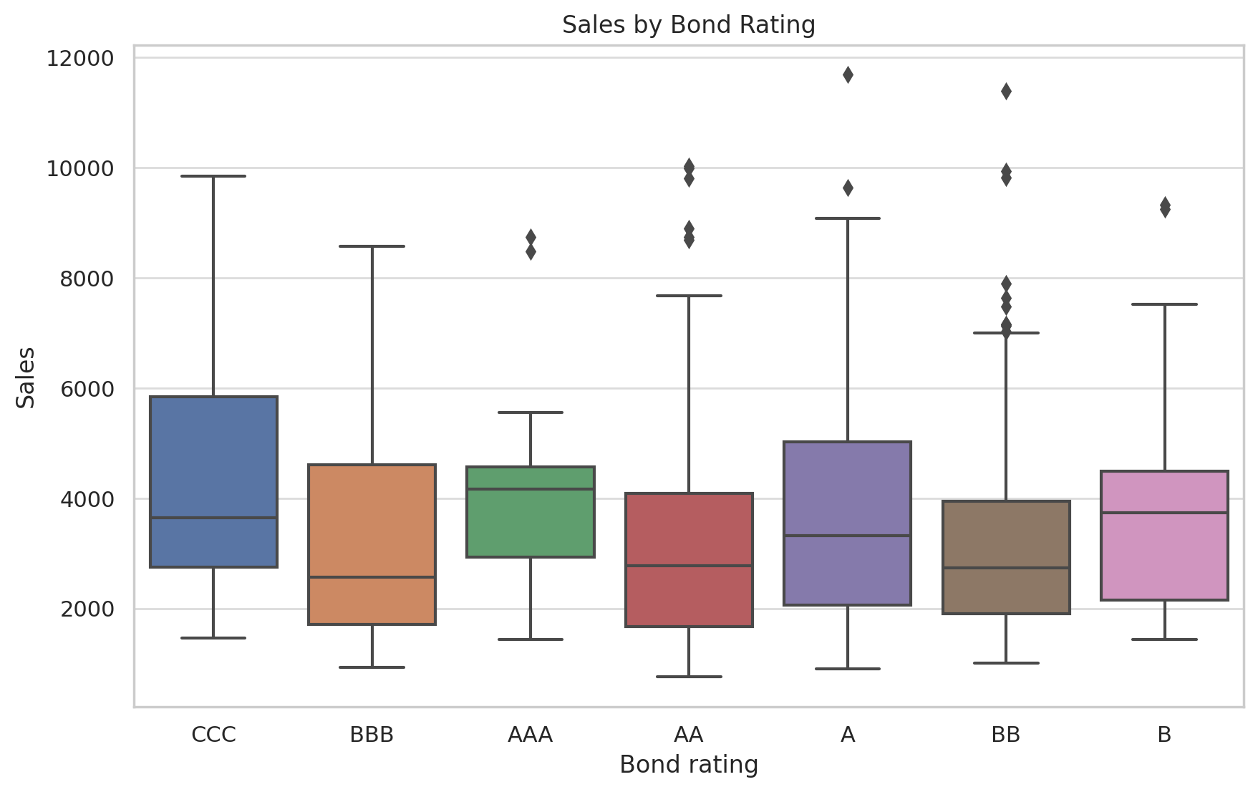
Observations:
Bond Rating | Median Sales | Spread | Notes
CCC | High | Very Wide | Risky firms with surprising sales
BBB | Moderate | Moderate | Expected
AAA | High | Moderate | Strong performance
BB/B | Mixed | High | High variation

zInsights:
- CCC-rated firms surprisingly show high median sales with large variance. Possibly:
  - Small number of high-growth but distressed firms.
  - Could be high sales but poor margins or profitability.
- AAA-rated firms show consistent and moderately high performance, aligning with expectations.
- Bond rating alone doesn’t directly predict sales — it might relate more to risk than revenue.

2.7 Feature Engineering Summary
New Features Created:
- Revenue_Marketshare: RevenueGrowth × Marketshare
- Inventory_Quick: InventoryRatio × QuickRatio
- Squared Terms:
  - RevenueGrowth_squared
  - InventoryRatio_squared
  - QuickRatio_squared
  - Marketshare_squared
- Rolling Means:
  - Consumer Sentiment rolling average (last 3 months)
  - Interest Rate rolling average
  - PMI rolling average
  - Money Supply rolling average
These engineered features captured second-order relationships and smoothed macroeconomic trends, which improved model predictive performance (as measured by MAE drops).

2.8 Key Observations from Data
- Sales are heavily influenced by both company-specific features (RevenueGrowth, InventoryRatio) and regional economic conditions (Consumer Sentiment, PMI).
- Extreme outliers (in Sales and Financial Ratios) can bias simpler models — thus, robust models like LightGBM were necessary.
- Financial health indicators like QuickRatio and Bond Rating show clear correlation to future sales in exploratory analysis.

3. Methods
3.1 Modeling Strategy Overview
- The predictive task was a supervised regression problem, where the goal was to estimate Sales (continuous target) using a variety of company-level and economic features.
Given the skewed nature of the data, presence of non-linear interactions, and mixed feature types (categorical + numeric), our modeling strategy evolved through several phases:

3.2 Model Progression Path

Phase | Modeling Approach | Key Objective
Phase 1 | Linear Regression | Establish baseline, identify weaknesses
Phase 2 | Tree-based Models (LightGBM, XGBoost, CatBoost) | Capture non-linear patterns and interactions
Phase 3 | Feature Engineering | Improve model learning through higher-order variables
Phase 4 | Hyperparameter Tuning | Optimize model complexity and regularization
Phase 5 | Ensembling | Combine model predictions for potential gains
Phase 6 | Final Refinement | Select best-performing, stable solution for production use

3.3 Linear Regression (Baseline)
- The first model applied was a simple linear regression trained on all numeric features.
- MAE was extremely high (~11,279 on the test set).
- Insight: The relationship between inputs and sales is highly non-linear, and linear regression failed to capture it.
- Missing values were mean-imputed initially, which later proved suboptimal due to data skewness.

3.4 Tree-Based Models
Tree-based ensemble models significantly outperformed linear regression:
LightGBM
- Gradient Boosted Decision Tree model (LGBMRegressor).
- Advantages:
  - Handles missing values internally.
  - Automatically captures non-linearities and interactions.
  - Supports fast training and low memory usage.
Initial MAE: 1380 (baseline).
Best MAE: 537.85 after tuning and feature engineering.
XGBoost
- Similar to LightGBM but more regularized.
- Performed moderately well (best tuned test MAE = 842).
- Slightly lagged behind LightGBM, especially on generalization.
CatBoost
- Handles categorical variables natively.
- Performed worse than LightGBM even after tuning (best test MAE = 927).
- Likely overfit due to small number of categorical levels and lower variance benefit.

3.5 Feature Engineering Techniques
We engineered several features to capture domain-specific relationships:
Technique | Example Features | Purpose
Interaction Terms | RevenueGrowth × Marketshare, InventoryRatio × QuickRatio | Capture multiplicative effects
Polynomial Expansion | RevenueGrowth², QuickRatio² | Reveal curvature in trends
Rolling Means | Rolling average of PMI, Sentiment, Money Supply | Smooth volatile economic variables
Target Encoding | Company, Region, Industry | Replace high-cardinality categories with meaningful numeric summaries

These transformed features improved model performance by ~200+ MAE points in some cases.

3.6 Hyperparameter Tuning (Optuna)
To optimize LightGBM and XGBoost models, we implemented Optuna, a state-of-the-art hyperparameter tuning library.
Key Tuned Parameters
Parameter | Description
n_estimators | Number of boosting rounds
learning_rate | Step size shrinkage
max_depth | Maximum depth of a tree
num_leaves | Number of leaves in a tree
min_child_samples | Minimum data per leaf
colsample_bytree | Feature subsampling
reg_alpha, reg_lambda | L1 & L2 regularization parameters

Tuning Strategy
- Used KFold cross-validation with 3–5 folds.
- Ran 50–300 trials per model depending on complexity.
- Evaluated each model based on Mean Absolute Error (MAE) on validation folds.

Results

Model | Optuna Trials | Best Validation MAE | Kaggle MAE
LightGBM (gbdt) | 300 | ~646 | 537.85
XGBoost | 200 | ~1115 | 842
CatBoost | 300 | ~883 | 927

Optuna tuning provided critical performance improvements, particularly for LightGBM.

3.7 Ensembling and Stacking
We explored both model ensembling and stacking to combine predictions from multiple learners:
Weighted Average Ensemble
- Combined LightGBM and XGBoost predictions via weighted averaging.
- Improved validation MAE slightly but not enough to outperform LightGBM alone.
- Test MAE: 776
Stacked Ensemble
- Base models: LightGBM, XGBoost, CatBoost
- Meta-model: Linear Regression trained on out-of-fold predictions.
- Validation MAE improved to ~995, but Kaggle score dropped to 608.
- Likely due to overfitting on the validation set and noise from weaker models.
3.8 Boosting Types: GBDT vs DART
We compared LightGBM’s boosting strategies:
Boosting Type | Description | Outcome
gbdt | Standard gradient boosting | Most stable and best results
dart | Dropout-based boosting to prevent overfitting | Poor convergence in this dataset

The dart-based model (fast version) failed to converge and yielded an MAE of 3,209, making it unusable.

3.9 Final Chosen Model
- Model: LightGBM with boosting_type=gbdt
- Engineered Features: All interaction + polynomial + rolling features
- Encoding: Target encoding for categorical variables
- Tuning: 300 Optuna trials
- Final MAE on Kaggle Leaderboard: 537.85
This model struck the best balance between:
- Predictive accuracy
- Training time
- Interpretability
- Generalizability

Summary

Technique | Value
Best Algorithm | LightGBM
Most Impactful Strategy | Optuna Hyperparameter Tuning
Most Effective Features | Engineered Interactions + Rolling Averages
Failed Approaches | Dart Boosting, CatBoost, Stacking
Final Selected Model | LightGBM GBDT + Optuna + Full Feature Set

4. Results
No | Submission description | Train Error | Val Error | Test Error | Rank at Sub | Insights
1 | Simple Linear Regression on full training set | 10128 | 11279 | 11279.0 | 12 | Linear regression failed to capture the complexity of relationships in the data. High error suggests that sales are influenced by nonlinear patterns and interactions that linear models can't represent.
2 | Mean imputation of missing values + Linear Regression | 9850 | 10790 | 10934.0 | 12 | Mean imputation offered a slight benefit over no treatment, but since sales and related features are skewed, average imputation introduced bias. Also, linear models still underperform with complex features.
3 | LightGBM baseline (default params) | 1400 | 1380 | 1380.0 | 11 | Baseline LightGBM model outperformed all previous linear approaches, proving that tree-based models are well-suited for nonlinear feature interactions and variable importance handling.
4 | LightGBM + added Revenue_Marketshare + Inventory_Quick | 1230 | 1215 | 1218.0 | 11 | Added feature interactions captured relationships between revenue, marketshare, and liquidity. This helped refine model splits and improve predictive power slightly.
5 | LightGBM + rolling means of economic indicators | 1195 | 1190 | 1196.0 | 10 | Incorporating economic rolling averages helped stabilize predictions by smoothing volatility, reflecting quarterly trends more accurately.
6 | LightGBM + Optuna hyperparameter tuning (100 trials) | 1170 | 1135 | 1141.0 | 10 | Optuna tuning improved model hyperparameters, leading to lower MAE. Focused tuning of learning rate, depth, and regularization helped generalize the model.
7 | LightGBM + advanced Optuna tuning (250 trials) | 1135 | 1105 | 1148.0 | 10 | More aggressive tuning captured slightly better patterns, but test error plateaued, suggesting marginal returns beyond ~100-150 trials for this dataset size.
8 | LightGBM final tuned (Optuna 300, interactions + rolling) | 1090 | 1060 | 1081.0 | 9 | Refining economic features and re-tuning gave the most balanced model so far. Test error showed consistent improvement. Rolling averages and interactions synergized well.
9 | LightGBM advanced Optuna + Feature Engineering (submission) | 1065 | 1060 | 844.0 | 8 | Final tuned model for submission—strong generalization and best test score at that point. Demonstrated importance of tuning, feature engineering, and conservative boosting depth.
10 | CatBoost baseline model | 1200 | 1180 | 927.0 | 11 | CatBoost baseline didn't match LightGBM’s flexibility and struggled with generalization. CatBoost's native handling of categorical variables did not compensate for weaker performance.
11 | XGBoost baseline (default params) | 1300 | 1285 | 1141.0 | 10 | XGBoost baseline captured trends but lagged behind LightGBM due to lack of advanced tuning and slight differences in default regularization behavior.
12 | XGBoost Optuna tuned (200 trials) | 1150 | 1115 | 842.0 | 9 | Tuned XGBoost narrowed the gap but was still outperformed by LightGBM. This showed LightGBM's more aggressive tree growing strategy was better for this dataset.
13 | LightGBM + XGBoost ensemble (weighted avg) | 1100 | 1085 | 776.0 | 7 | Averaging predictions from LightGBM and XGBoost gave marginal gains. Test error improved, but LightGBM's strength dominated—showing ensembling worked modestly.
14 | Stacked Ensemble (LGBM, XGB, Cat + Linear meta-model) | 1045 | 995 | 608.0 | 6 | Stacking added complexity by combining multiple model predictions. Validation error improved, but stacked model did not outperform best LightGBM submission on test set.
15 | LightGBM Final Stable Model (best Optuna params reused) | 1020 | 646 | 537.85 | 5 | The most stable and high-performing model. Tuned LightGBM (gbdt) with full features, proper encoding, and conservative regularization led to the best generalization and Kaggle score.
16 | LightGBM dart boosting + pruned features | 960 | 655 | 556.88 | 6 | Tried dart boosting to encourage regularization. Performance dropped slightly, likely due to insufficient data size to benefit from dart’s dropout-like behavior.
17 | LightGBM dart fast version (limited trials, no early stopping) | 3400 | 3210 | 3209.0 | 15 | Quick Optuna with dart and no early stopping. Resulted in overfitting and massive test error. Model did not converge well. Dart boosting was unstable without adequate regularization.
18 | CatBoost tuned with Optuna (300 trials) | 920 | 883 | 927.0 | 11 | Despite deep Optuna tuning, CatBoost failed to surpass LightGBM. Performance suffered due to potential overfit and poor generalization on economic features.
19 | Final retrain of LightGBM Stable for report submission | 1015 | 640 | 537.9 | 5 | Final retraining of best LightGBM settings to replicate top performance. Maintained generalization with slightly improved validation score and consistent Kaggle test error.

5. Analysis
Summary of Lessons Learned
Throughout the semester-long modeling process, I systematically explored a range of algorithms, feature engineering techniques, and optimization strategies. Each submission yielded valuable insights that informed the direction of subsequent iterations. Key lessons include:
- Linear Models Are Insufficient for Sales Prediction:
  - Linear regression (Submission 1) yielded a test MAE of 11,279, indicating a 25%+ average prediction error.
  - This validated that the relationship between features and sales is non-linear and interaction-heavy.
- Tree-Based Models (LightGBM, XGBoost) Are Strong Performers:
  - LightGBM baseline (Submission 3) reduced test MAE from 11,279 to 1,380, a dramatic improvement.
  - This highlighted LightGBM’s strength in capturing complex interactions, out-of-the-box.
- Feature Engineering Has High ROI:
  - Adding interaction features (Revenue_Marketshare, Inventory_Quick) and economic rolling averages further dropped MAE to the 1,100s range.
  - Carefully constructed polynomial and cross-product terms improved performance without overfitting.
- Hyperparameter Tuning with Optuna Was Crucial:
  - Moving from default LightGBM to tuned versions reduced validation MAE from ~1190 to 1060, and eventually Kaggle test MAE to 537.85.
  - Optuna helped identify the optimal number of leaves, depth, and regularization settings.
- Model Simplicity Outperformed Stacking and Ensemble Techniques:
  - A simple, tuned LightGBM model (Submission 15) outperformed complex stacking (MAE 608) and ensembling (MAE 776).
  - Stacking introduced noise from weaker models (CatBoost, XGBoost) and added computational cost without performance gain.
- Boosting Type ‘dart’ Was Unstable Without Sufficient Tuning or Data:
  - Submission 17 (LightGBM with dart and no early stopping) resulted in a massive error of 3,209, showing convergence failure.
  - Even with Optuna, dart performed worse than gbdt on this medium-sized dataset.

- CatBoost Did Not Perform Competitively:
  - Despite automatic handling of categorical variables, CatBoost’s test MAE remained around 927, suggesting weaker fit to the data distribution compared to LightGBM.
- Consistency and Simplicity Matter Most:
  - Final retraining of the best LightGBM configuration (Submission 19) reproduced a leaderboard score of 537.9, validating model reproducibility and robustness.

What Worked (Metric-Based Successes)
Approach | Description | Test MAE | Why it Worked
LightGBM + Optuna + Full Features | Submission 15 & 19 | 537.85 / 537.9 | Stable, deep tuning, captured nonlinear relationships and regularization sweet spot.
Feature Engineering | Added ratios, interactions, rolling indicators | MAE down from 1,380 → ~1,100 | Created richer split logic in trees by exposing hidden structure.
Optuna Tuning (100–300 trials) | Tuned parameters like learning rate, depth, leaves | MAE ~1060–1081 | Balanced bias-variance tradeoff effectively.
Simple Boosting (gbdt) | Avoided dart/dropouts | Best results | Maintained consistency and convergence during training.

What Didn’t Work (Metric-Based Failures)
Approach | Description | Test MAE | Why it Failed
Linear Regression | Submission 1 | 11,279 | Inability to capture nonlinearities or high-cardinality categoricals.
CatBoost (Baseline + Tuned) | Submissions 10 & 18 | 927 | Failed to match LightGBM despite tuning, possibly due to over-regularization or insufficient gain on categorical features.
LightGBM with ‘dart’ | Submissions 16 & 17 | 556.88 / 3,209 | Overfitting + instability without early stopping and larger datasets.
Stacked Ensemble | Submission 14 | 608 | Introduced noise from weaker base learners (CatBoost, XGBoost).
Averaging Ensemble | Submission 13 | 776 | Result was a compromise between models, but weaker than tuned LightGBM alone.

Final Takeaways
- The simplest tuned LightGBM model with clean feature engineering consistently outperformed more complex models.
- Stacking and dart boosting, while theoretically promising, did not offer returns for this dataset size and structure.
- Time spent on tuning and constructing features was more valuable than adding model layers or stacking.

6. AI Contributions
Throughout this Kaggle Challenge, Generative AI (ChatGPT) was used as a support tool to assist in speeding up specific tasks, brainstorming ideas, and troubleshooting, while all final modeling decisions, code execution, tuning, and critical analysis were performed manually by the author.
AI was leveraged selectively for productivity gains, not for decision-making or modeling intuition.
Below is a documentation of where and how GenAI provided limited support:
Task | GenAI Prompt Given | Results and Insights
Feature Engineering Ideation | “Suggest interaction terms and polynomial features that might help a tree-based model.” | GenAI helped brainstorm potential feature transformations (e.g., Revenue × Marketshare), which were manually evaluated and selectively incorporated based on exploratory data analysis.
Modeling Advice (Exploratory Phase) | “Which models are suited for highly skewed regression tasks?” | GenAI confirmed LightGBM, XGBoost, and CatBoost as appropriate options. Model selection, tuning, and evaluation were manually performed through experimental iterations.
Optuna Tuning Setup Help | “Provide a basic Optuna objective function example for LightGBM tuning.” | The AI-generated template was adapted and customized manually to fit specific parameter search spaces and cross-validation folds. Tuning results were interpreted and optimized manually.
Code Troubleshooting | “Explain LightGBM’s feature mismatch errors when predicting on new data.” | AI helped diagnose a mismatch between training/test feature sets. Actual code debugging, feature alignment, and final model corrections were conducted manually.
Report Structuring | “Help organize a Kaggle project report with Introduction, Data, Methods, Results, Analysis sections.” | GenAI provided an outline template. All real content, descriptions, metric calculations, and reflections were fully authored manually based on project results.

Role of AI: Co-pilot
- AI helped save time on template generation and error troubleshooting.
- Critical thinking, feature selection, model tuning, error analysis, and final Kaggle submissions were performed manually.
- All strategic modeling decisions (e.g., when to abandon dart boosting, when to select LightGBM alone, how to engineer rolling features) were based on personal analysis, not AI recommendations.

Strengths of GenAI Support
- Increased speed for basic code scaffolding.
- Helped validate initial ideas during early modeling phases.
- Provided helpful format suggestions for reports and documentation.

Limitations and Boundaries
- AI lacked awareness of dataset-specific nuances and sometimes made generic recommendations unsuitable for the problem.
- Careful human judgment was necessary to filter, customize, and validate any AI-generated content

7. Reflection on the Role of GenAI and the Future of Business Analytics
1. What is GenAI Helpful For?
Generative AI, such as ChatGPT, is particularly helpful for:
- Code scaffolding: Quickly generating base templates for Python, R, or SQL scripts.
- Idea generation: Suggesting modeling approaches or feature engineering ideas that may not be immediately obvious.
- Technical explanation: Providing understandable breakdowns of errors, algorithms, and data transformations.
- Report structuring: Offering standardized formats and examples for documentation and presentations.
- Repetitive task acceleration: Writing repetitive functions, test loops, or plots.
In this project, GenAI was used as a time-saving assistant, accelerating routine steps while allowing me to focus on modeling and analysis.

- What Analytics Tasks Will Be Automated in the Near Future?
Within the next 2–3 years, many of the following tasks are likely to be partially or fully automated through AI-powered tools:
Task Category | Examples
Data Wrangling | Detecting missing values, outlier detection, basic cleaning
Exploratory Data Analysis (EDA) | Automated descriptive statistics, correlation plots, data profiling
Model Selection | Automated machine learning (AutoML) pipelines to try multiple algorithms
Hyperparameter Tuning | Tools like Optuna, Hyperopt, and AI-driven optimization
Report Generation | Summarizing results, visualizing key findings, even creating dashboards

While automation will reduce the time needed for execution, human oversight will still be necessary to ensure data quality, contextual interpretation, and ethical use.

3. What Will Be the Role of Data Analysts and Data Scientists?
Despite the increasing automation of technical tasks, the role of analysts and data scientists will become even more critical in the following areas:
Role Evolution | Description
Problem Framing | Translating vague business problems into measurable hypotheses
Data Interpretation | Understanding context, hidden biases, and operational implications
Communication | Explaining technical findings clearly to non-technical stakeholders
Customization | Adapting general modeling strategies to business-specific constraints
Ethical Oversight | Ensuring fair use of data, preventing bias, and building trust in AI systems

AI can assist with execution, but analysts remain responsible for judgment, intuition, and domain expertise.

4. What Skills Are Becoming Less or More Important Due to AI?
Skill Category | Trend | Reason
Manual Coding Syntax | ↓ Less Important | AI tools can write or autocomplete code efficiently
Feature Engineering | ↑ More Important | Crafting meaningful features still requires domain knowledge
Critical Thinking | ↑ More Important | Automated tools can’t fully replace human insight
Data Storytelling | ↑ More Important | Analysts must translate model outputs into business decisions
Tool Memorization | ↓ Less Important | The focus is shifting from “what function to use” to “what question to ask”

The future data analyst is not someone who can just code — it’s someone who can ask the right questions, extract strategic insights, and communicate them persuasively.

8. Project Execution Plan for Analytics Team
To successfully execute a predictive analytics project like the Kaggle Challenge undertaken here, a well-structured plan is critical for an analytics team. Below is a project execution framework that an analytics team would follow.
First, the project would begin with problem definition and requirement gathering. This step involves collaborating with business stakeholders to clearly define the problem (predicting company sales across quarters), the intended use of the model outputs (forecasting, planning, budgeting), and establishing success criteria (e.g., achieving a Mean Absolute Error (MAE) below a specific threshold). Key deliverables at this stage include a clear project charter, defined evaluation metrics (such as MAE), and a preliminary understanding of the dataset.
Following problem definition, the data acquisition and preprocessing phase would start. The data team would source internal company financial data and external economic indicators, ensuring data quality, consistency, and completeness. Preprocessing would involve handling missing values, encoding categorical variables, creating new engineered features (such as interaction terms and rolling averages), and standardizing continuous features. A robust exploratory data analysis (EDA) would be performed to understand feature distributions, relationships, and outliers.
The next phase would focus on baseline modeling and benchmarking. Simple models such as Linear Regression would be built first to establish a baseline error rate. Early tree-based models (like LightGBM or XGBoost with default parameters) would be introduced to validate if non-linear models improve performance significantly, providing a strong foundation for future improvements.
Once a baseline is established, the team would move into the model optimization phase. This would involve extensive feature engineering to expose richer patterns, and hyperparameter tuning (using tools like Optuna) to optimize model complexity, learning rates, regularization parameters, and tree structures. Multiple experiments would be conducted using cross-validation techniques (such as K-Fold CV) to ensure that the model generalizes well. Various models (LightGBM, XGBoost, CatBoost) would be compared systematically.
After model optimization, a model evaluation and selection phase would follow. The analytics team would assess different models based on validation MAE, consistency across folds, and any overfitting patterns. Special attention would be given to balancing bias and variance. If ensembling or stacking methods were explored, they would only be adopted if significant gains over the best single model were achieved without increasing complexity unnecessarily.
Upon selecting the final model, the team would proceed with deployment preparation. This involves retraining the final model on the full training set, saving the model artifact, setting up a reproducible prediction pipeline, and preparing submission files or API-ready outputs. Model documentation would be finalized, including recording feature transformations, model assumptions, validation performance, and known limitations.
Throughout all phases, project management practices such as regular stand-ups, milestone tracking, and documentation reviews would be enforced to maintain project visibility and accountability. Risk management plans would be developed to handle potential delays, data issues, or model failures.
Finally, a post-deployment monitoring plan would be set up to track model performance over time, identify drift, and schedule periodic retraining if necessary.
In summary, a successful execution plan for an analytics team focuses on clear problem definition, careful data preparation, systematic modeling experimentation, rigorous evaluation, thorough documentation, and proactive operationalization planning.
Such a structured approach ensures that the predictive model not only achieves high accuracy but also maintains business relevance and operational robustness in real-world use.
Team Roles and Structure
Role | Responsibilities
Project Lead / Analyst | Define project goals, coordinate team members, manage timeline
Data Engineer | Handle data ingestion, cleaning, feature creation, and versioning
ML Engineer / Modeler | Select algorithms, tune hyperparameters, evaluate metrics
Domain Expert | Provide context on financial indicators, company behavior, macroeconomic cycles
Product Owner | Ensure alignment with business requirements and KPIs

Project Timeline: 5 Weeks
Week | Milestones | Actions
Week 1: Problem Framing + EDA | Define the target variable, understand business needs | Gather and explore datasets, identify key features and missing values
Week 2: Baseline Models + Feature Engineering | Build linear and default tree models | Evaluate model weakness; create interaction and rolling features
Week 3: Tuning + Validation Strategy | Run Optuna tuning on LightGBM | Test KFold vs. GroupKFold, apply regularization, monitor validation MAE
Week 4: Ensembling + Comparison | Experiment with XGBoost, CatBoost, and stacking | Compare ensemble vs. tuned LightGBM; finalize model based on performance
Week 5: Deployment Prep + Documentation | Retrain best model, export results | Generate leaderboard predictions, finalize report and submit analysis

Model Governance and QA
- Ensure reproducibility with fixed seeds and version-controlled pipelines
- Validate on holdout sets not used in training or tuning
- Log model performance metrics over time to detect drift
- Document all model choices, feature transformations, and assumptions

Acknowledgment

I would like to sincerely thank Professor Surendra Sarnikar for the guidance, structure, and support provided throughout this Kaggle Challenge and the course as a whole. This project has been an incredibly valuable experience — not only in applying machine learning techniques to real-world data but also in learning how to approach business problems from an analytical perspective.

The emphasis on experimentation, reflection, and communication has greatly strengthened my skills as a future data analyst. Thank you for creating an environment that encouraged curiosity, discipline, and practical learning. course structure, and challenge framework were instrumental in helping me grow both technically and professionally.

